
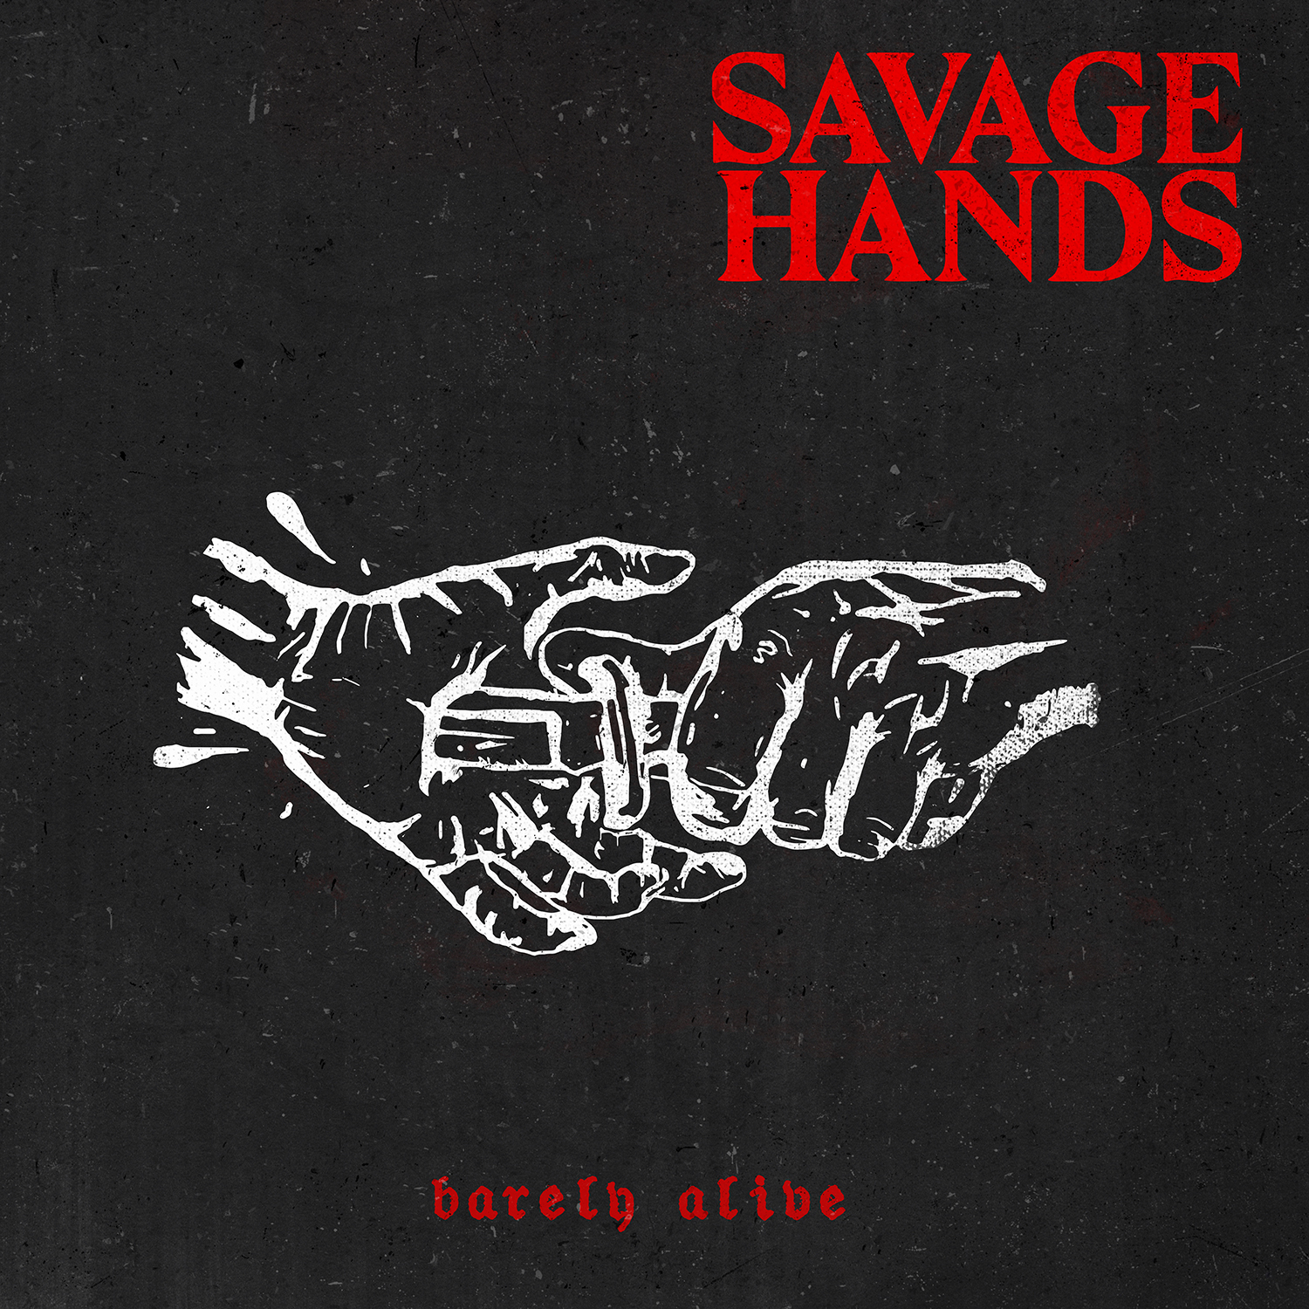

SAVAGE HANDS

»Barely Alive«

Out: March 2nd, 2018

Line up: | SAVAGE HANDS online:
Mike Garrow | vocals  Justin Hein | guitar/vocals  Ryan Evans | guitar  Nathan O'Brien | bass/vocals  Jonny Melton | drums | https://www.facebook.com/SavageHands/  https://twitter.com/savagehandsmd  http://sharptonerecords.co/
Most people are fundamentally good—but sometimes, extraordinary circumstances bring out the most bitter, unkind and aggressive elements in even the most taciturn of folk. Lies, betrayal, cheating, stealing—it piles up and before you can stop yourself, in a fit of passion, you snap and let your true feelings show. That sincere, sinister, passive-aggressive emotional energy defines relative newcomers SAVAGE HANDS, who take a sharp, fun post-hardcore edge and lacquer it with a thin layer of dissonance and punch to give it just what the band needs to cut right into the listener's head and stay lodged there for weeks. For anyone from any walk of live, SAVAGE HANDS are an act with incredible appeal and unstoppable energy bound to make themselves an instant favorite in the ears and hearts of the heavy music community.
Born from the ashes of defunct bands in Maryland & Virginia, SAVAGE HANDS might be a young band, but they certainly don't lack experience. The collective members have ample experience in writing and playing their music to audiences in support of several noteworthy nationwide tours—experience enough to write and record an EP with Andrew Baylis (MY ENEMIES & I; SYLAR) which garnered the attention of SharpTone Records. Filled with catchy hooks that weave in and out of blood-pumping, adrenaline-spiking verses and visceral, gut-busting breakdowns, SAVAGE HANDS’ debut effort is one that makes the ground shake and inspires an emotional, energetic uproar within the listener. Never sacrificing a sense of poetic wit and sharp-tongued flair for their equally engaging punchy musicianship, SAVAGE HANDS' debut effort in early 2018 is just the first of many things bound to craft a stellar—and savage—future.

